MEMORIAL STADIUM
Friday, October 29
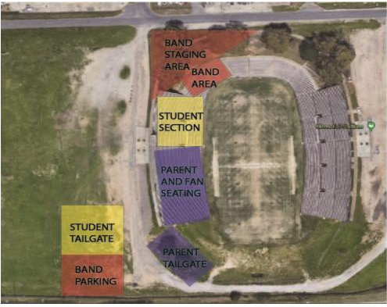
Band Night Participants Check-In
INTERSTATE

